**WEEK 1 ASSIGNMENT**

**Picture 1**

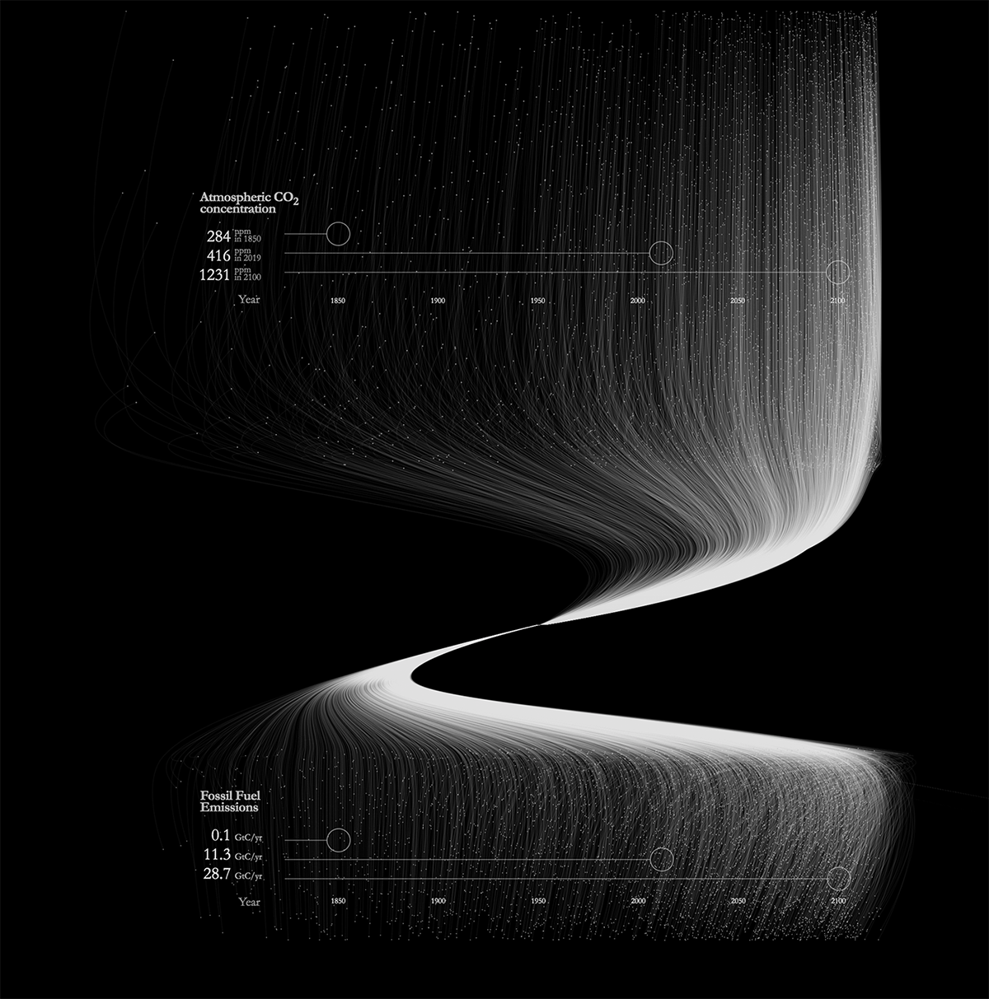

It is a very good and creative visualization when we dealing 2 parameters comparing with timeline. The colour and design they used were great, which makes us to feel interesting. We can see the circles, with values on left side at particular years for Fossil fuel Emissions and Atmosphere CO2 Concentration which adds clear detailing to attributes. At final its great with its colour, design and detailing. **(Awesome)**

**Picture 2**

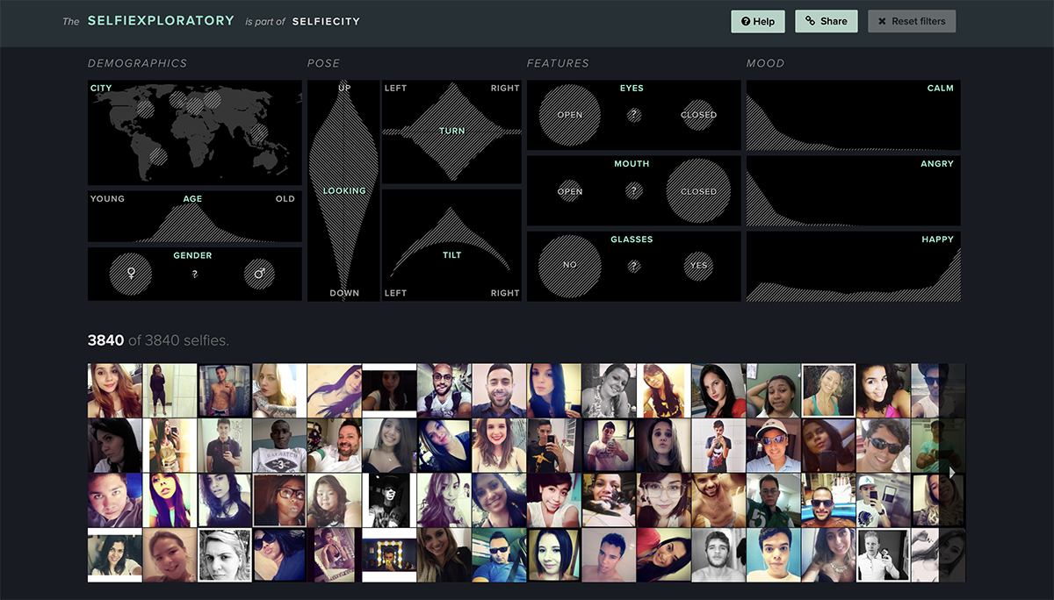

Its very difficult to handle this example of Data visual representation of selfie records but they made it very great by classifying the data to attributes like DEMOGRAPHICS, POSE, FEATURES and MOOD and sub categorise as CITY, AGE, GENDER, LOOKING, TURN, TILT, EYES, MOUTH, GLASSES, CALM, ANGRY, HAPPY and each and every image is in same font and colour gradient is good which makes this representation also awesome. To make difference among features they used different shapes for different features which makes this visualization great and interesting. **(AWESOME)**

**Picture 3**

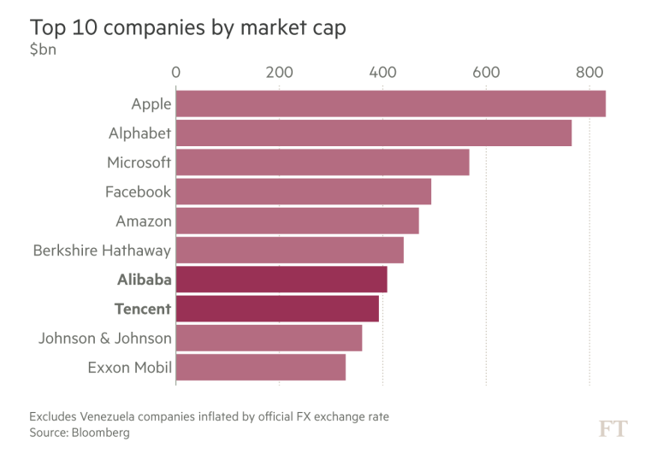

This data visualization is representing Market cap of Top 10 companies in World. Where you can see market cap in bn$ on top and company names on left end. They used similar colour for all companies in bar chart which looks good and we can see highlighting Alibaba and Tencent makes stand out towards other companies even though it is not a top market cap company (Apple). Finally, it’s a simple and cool data visualization with great detailing **(Good)**

The three examples above are considered good because they offer a clear view to the audience, thanks to their detailed use of colour gradients and effective designs. They successfully convey the intended message and achieve the desired impact.

**Picture 4**

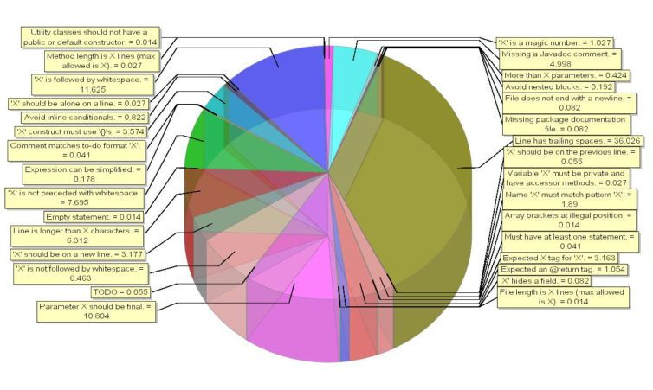

This Data visualization picture discussing about a code block which has a main variable ‘x’. here they want to mention each detail of code which is at first place not that much important at all. We have to question the required outcome and exclude unnecessary and plot the main important things to our outcome. Data visualization method is not good in this scenario. if they want to show every data in one place. For this scenario they can categorise the important and not important once and go with good suitable data visualization technique. Furthermore, they used 3D which is Soo odd for audience to view and lots of data points added for each block which makes this very complex and no one wants to see every detail they are briefing. Overall, it’s not recommended **(BAD)**

**Picture 5**

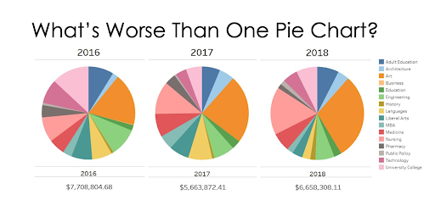

This Data visualization representing various categories with total amount at years of 2016, 2017, 2018 In a pie charts. Here they know what they want us to see but desired output is not conveyed correctly. We cannot see and understand the difference among up and down of categories from this visualization which makes it bad as outcome itself not conveyed. **(BAD)**

**Picture 6**

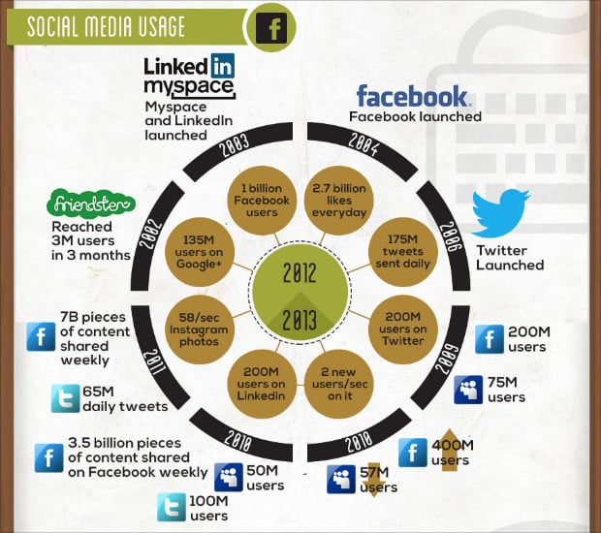

This visualization talking about users in social media but main drawback is it is clumsy due to colours logos and info not in good format. These make audience out of interest. They should go with classification in order and make some good visualization according to it so that audience can notice what actually we are showing them. We can see at centre 2012 and 2013 which rising so many questions to me. So, make sure the data is classified and presented in proper way, so we can understand in better way **(BAD)**

The three examples above are not ideal because they lack clarity and fail to provide a clear view to the audience. Their use of colour gradients is confusing, and the designs are ineffective. As a result, they do not convey the intended message and fail to achieve the desired impact.